

**Excel Assignment - 15**

Dataset:

https://docs.google.com/spreadsheets/d/1IRSEnmgz8Ro276- GslknRNk0zlrB5CZH1YrnT71kqFM/edit?usp=sharing

Use the above dataset and answer the following questions.

1. Create a Pivot table and show what the main export product is?

1. Create a bar graph showing the amount spent for each product?

1. Create a Pivot table to show The sales in each city

1. Create a chart showing the amount spent for each product in each city.

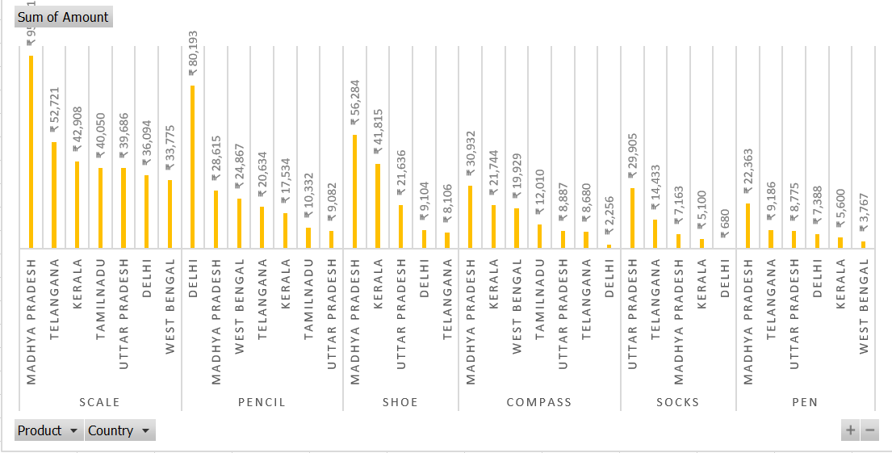

Have also uploaded excel file on github named as “Excel Assignment Dataset 2.xlsx”, from that file results are pasted over here